**A**

***PROJECT REPORT***

*on*

**Online Examination Portal**

*Submitted in partial fulfilment of the requirements for the degree of*

**BACHELOR OF TECHNOLOGY**



Session: - 2024

Under Guidance of

Mr. Aaditya Maheshwari Assistant Professor

Computer Science & Engineering

Submitted by

Abir Choudhury (20ETCCS002) Asim Ali (20ETCCS014) Harshit Paneri (20ETCCS049)

Priyanshu Arora (20ETCCS093)

Yash Mali (20ETCCS118)

Yash Soni (20ETCCS119)

8th Sem (CSE)

**DEPARTMENT OF COMPUTER SCIENCE AND ENGINEERING TECHNO INDIA NJR INSTITUTE OF TECHNOLOGY, UDAIPUR-313001 2024**

**A**

***PROJECT REPORT***

*on*

**Online Examination Portal**

*Submitted in partial fulfilment of the requirements for the degree of*

**BACHELOR OF TECHNOLOGY**



**Session: - 2024**

Under Guidance of

Mr. Aaditya Maheshwari Assistant Professor

Computer Science & Engineering

Submitted by

Abir Choudhury (20ETCCS002) Asim Ali (20ETCCS014) Harshit Paneri (20ETCCS049)

Priyanshu Arora (20ETCCS093)

Yash Mali (20ETCCS118)

Yash Soni (20ETCCS119)

8th Sem (CSE)

**DEPARTMENT OF COMPUTER SCIENCE AND ENGINEERING TECHNO INDIA NJR INSTITUTE OF TECHNOLOGY, UDAIPUR-313001 2024**



Department of Computer Science and Engineering Techno India NJR Institute of Technology, Udaipur-313001

## Certificate

This is to certify that project work titled **“Online Examination Portal”** by **Abir Choudhury** was successfully carried out in the Department of Computer Science and Engineering, TINJRIT and the report is approved for submission in the partial fulfillment of the requirements for award of degree of Bachelor of Technology in Computer Science and Engineering.

Mr. Aaditya Maheshwari Dr. Rimpy Bishnoi

Assistant Professor Professor and HOD

Computer Science & Engineering Dept. of CSE TINJRIT, Udaipur

Date Date



Department of Computer Science and Engineering Techno India NJR Institute of Technology, Udaipur-313001

## Certificate

This is to certify that project work titled **“Online Examination Portal”** by **Asim Ali** was successfully carried out in the Department of Computer Science and Engineering, TINJRIT and the report is approved for submission in the partial fulfillment of the requirements for award of degree of Bachelor of Technology in Computer Science and Engineering.

Mr. Aaditya Maheshwari Dr. Rimpy Bishnoi

Assistant Professor Professor and HOD

Computer Science & Engineering Dept. of CSE TINJRIT, Udaipur

Date Date



Department of Computer Science and Engineering Techno India NJR Institute of Technology, Udaipur-313001

## Certificate

This is to certify that project work titled **“Online Examination** **Portal”** by **Harshit Paneri** was successfully carried out in the Department of Computer Science and Engineering, TINJRIT and the report is approved for submission in the partial fulfillment of the requirements for award of degree of Bachelor of Technology in Computer Science and Engineering.

Mr. Aaditya Maheshwari Dr. Rimpy Bishnoi

Assistant Professor Professor and HOD

Computer Science & Engineering Dept. of CSE TINJRIT, Udaipur

Date Date



Department of Computer Science and Engineering Techno India NJR Institute of Technology, Udaipur-313001

## Certificate

This is to certify that project work titled **“Online Examination Portal”** by **Priyanshu Arora** was successfully carried out in the Department of Computer Science and Engineering, TINJRIT and the report is approved for submission in the partial fulfillment of the requirements for award of degree of Bachelor of Technology in Computer Science and Engineering.

Mr. Aaditya Maheshwari Dr. Rimpy Bishnoi

Assistant Professor Professor and HOD

Computer Science & Engineering Dept. of CSE TINJRIT, Udaipur

Date Date



Department of Computer Science and Engineering Techno India NJR Institute of Technology, Udaipur-313001

## Certificate

This is to certify that project work titled **“Online Examination Portal”** by **Yash Mali** was successfully carried out in the Department of Computer Science and Engineering, TINJRIT and the report is approved for submission in the partial fulfillment of the requirements for award of degree of Bachelor of Technology in Computer Science and Engineering.

Mr. Aaditya Maheshwari Dr. Rimpy Bishnoi

Assistant Professor Professor & HOD

Computer Science & Engineering Dept. of CSE TINJRIT, Udaipur

Date Date



Department of Computer Science and Engineering Techno India NJR Institute of Technology, Udaipur-313001

## Certificate

This is to certify that project work titled **“Online Examination Portal”** by **Yash Soni** was successfully carried out in the Department of Computer Science and Engineering, TINJRIT and the report is approved for submission in the partial fulfillment of the requirements for award of degree of Bachelor of Technology in Computer Science and Engineering.

Mr. Aaditya Maheshwari Dr. Rimpy Bishnoi

Assistant Professor Professor & HOD

Computer Science & Engineering Dept. of CSE TINJRIT, Udaipur

Date Date



Department of Computer Science and Engineering Techno India NJR Institute of Technology, Udaipur-313001

## Examiner Certificate

This is to certify that the following student **Abir Choudhury** of final year B.Tech. (Computer Science and Engineering), was examined for the project work titled

***“Online Examination Portal”***

during the academic year 2023 – 2024 at Techno India NJR Institute of Technology, Udaipur

**Remarks:**

**Date:**

Signature Signature

(**Internal Examiner**) (**External Examiner**)

Name :- Name :-

Designation :- Designation:-

Department :- Department: -

Organization:- Organization:-



Department of Computer Science and Engineering Techno India NJR Institute of Technology, Udaipur-313001

## Examiner Certificate

This is to certify that the following student **Asim Ali** of final year B.Tech. (Computer Science and Engineering), was examined for the project work titled

***“Online Examination Portal”***

during the academic year 2023 – 2024 at Techno India NJR Institute of Technology, Udaipur

**Remarks:**

**Date:**

Signature Signature

(**Internal Examiner**) (**External Examiner**)

Name :- Name :-

Designation :- Designation:-

Department :- Department: -

Organization:- Organization:-



Department of Computer Science and Engineering Techno India NJR Institute of Technology, Udaipur-313001

## Examiner Certificate

This is to certify that the following student **Harshit Paneri** of final year B.Tech. (Computer Science and Engineering), was examined for the project work titled

***“Online Examination Portal”***

during the academic year 2023 – 2024 at Techno India NJR Institute of Technology, Udaipur

**Remarks:**

**Date:**

Signature Signature

(**Internal Examiner**) (**External Examiner**)

Name :- Name :-

Designation :- Designation:-

Department :- Department: -

Organization:- Organization:-



Department of Computer Science and Engineering Techno India NJR Institute of Technology, Udaipur-313001

## Examiner Certificate

This is to certify that the following student **Priyanshu Arora** of final year B.Tech. (Computer Science and Engineering), was examined for the project work titled

***“Online Examination Portal”***

during the academic year 2023 – 2024 at Techno India NJR Institute of Technology, Udaipur

**Remarks:**

**Date:**

Signature Signature

(**Internal Examiner**) (**External Examiner**)

Name :- Name :-

Designation :- Designation:-

Department :- Department: -

Organization:- Organization:-



Department of Computer Science and Engineering Techno India NJR Institute of Technology, Udaipur-313001

## Examiner Certificate

This is to certify that the following student **Yash Mali** of final year B.Tech. (Computer Science and Engineering), was examined for the project work titled

***“Online Examination Portal”***

during the academic year 2023 – 2024 at Techno India NJR Institute of Technology, Udaipur

**Remarks:**

**Date:**

Signature Signature

(**Internal Examiner**) (**External Examiner**)

Name :- Name :-

Designation :- Designation:-

Department :- Department: -

Organization:- Organization:-



Department of Computer Science and Engineering Techno India NJR Institute of Technology, Udaipur-313001

## Examiner Certificate

This is to certify that the following student **Yash Soni** of final year B.Tech. (Computer Science and Engineering), was examined for the project work titled

***“Online Examination Portal”***

during the academic year 2023 – 2024 at Techno India NJR Institute of Technology, Udaipur

**Remarks:**

**Date:**

Signature Signature

(**Internal Examiner**) (**External Examiner**)

Name :- Name :-

Designation :- Designation:-

Department :- Department: -

Organization:- Organization:-

## Preface

In today's rapidly evolving digital landscape, education has undergone a transformative shift, embracing the power of technology to enhance learning experiences. The advent of online examination systems has revolutionized the way assessments are conducted, offering unparalleled convenience, efficiency, and accessibility. This report delves into the development and implementation of our "Online Exam Management" platform, a cutting-edge solution tailored to meet the demands of modern educational institutions.

Recognizing the challenges posed by traditional paper-based examinations, our team embarked on a mission to create a robust, user-friendly, and secure online examination system. By leveraging the latest technological advancements, we aimed to streamline the examination process, enhance security measures, and provide a seamless experience for both students and educators alike.

Throughout this document, we will explore the intricate details of our platform, from its comprehensive feature set to the underlying architectural design. We will shed light on the innovative approaches we adopted to ensure the integrity of the examination process, safeguarding against potential vulnerabilities and ensuring a fair and unbiased assessment environment.

Furthermore, we acknowledge the invaluable contributions of renowned educational institutions and research organizations in shaping our understanding of best practices and industry standards. Their insights and expertise have played a pivotal role in guiding our development efforts, ensuring our platform aligns with the highest standards of academic excellence.

Join us on this journey as we delve into the intricacies of our "Online Exam Management" platform, unveiling its profound impact on the future of education. Together, let us embrace the transformative power of technology and pave the way for a more efficient, secure, and accessible examination experience for generations to come.

**ACKNOWLEDGMENT**

We take this opportunity to record our sincere thanks to all who helped us to successfully complete this work. Firstly, we are grateful to our **supervisor Mr. Aaditya Maheshwari** for his invaluable guidance and constant encouragement, support and most importantly for giving us the opportunity to carry out this work.

We would like to express our deepest sense of gratitude and humble regards to our **Head of Department Dr. Rimpy Bishnoi** for giving invariable encouragement in our endeavors and providing necessary facility for the same. Also, a sincere thanks to all faculty members of CSE, TINJRIT for their help in the project directly or indirectly.

Finally, we would like to thank my friends for their support and discussions that have proved very valuable for us. We are indebted to our parents for providing constant support, love and encouragement. We thank them for the sacrifices they made so that we could grow up in a learning environment. They have always stood by us in everything we have done, providing constant support, encouragement and love.

**Abir Choudhury (20ETCCS008) Asim Ali** **(20ETCCS016) Harshit Paneri (20ETCCS049) Priyanshu Arora (20ETCCS093) Yash Mali (20ETCCS118)**

**Yash Soni (20ETCCS119)**

## CONTENTS

|  |  |
| --- | --- |
| **Certificate** | i-vi |
| **Examiner Certificate** | vii-xii |
| **Preface** | xiii |
| **Acknowledgement** | xiv |
| **Content** | xv-xvii |
| **List of Figures** | xviii |
| **List of Tables** | xix |
| **List of Abbreviation/Symbols** | xx |
| **Chapter 1** INTRODUCTION | 1 |
| 1.1 Background and Motivation | 1 |
| 1.2 Objectives of the Project | 1 |
| 1.3 Overview of the Problem Statement | 2 |
| **Chapter 2** LITERAURE REVIEW | 3 |
| 2.1 Survey of Relevant Literature on Online Examination Systems | 3 |
| 2.2 Analysis of Existing Platforms and Initiatives in the Field | 3 |
| **Chapter 3** PROBLEM STATEMENT | 5 |
| 3.1 Classification of Online Examination Components | 5 |
| 3.2 Challenges in Traditional Examination Processes | 5 |
| 3.3 Evaluation of Challenges in Traditional Examination Methods | 6 |
| **Chapter 4** OBJECTIVE AND SCOPE | 8 |
| 4.1 Specific Goals of the Project | 8 |
| 4.1.1 Seamless Integration of Technology and Assessment | 8 |
| 4.1.2 Development of Comprehensive Online Examination Platform | 8 |
| 4.1.3 Enhancement of Academic Integrity and Student Well-being | 8 |
| 4.1.4 Cultivation of Academic Community | 9 |
| 4.2 Scope and Boundaries of the Work | 9 |
| 4.2.1 Online Platform Development | 9 |
| 4.2.2 Content Creation and Question Bank Management | 10 |
| 4.2.3 Community Building and Stakeholder Engagement | 10 |
| **Chapter 5** METHODOLOGY | 11 |
| 5.1 Detailed Explanation of Development Process | 11 |
| 5.1.1 Requirements Gathering and Analysis | 11 |
| 5.1.2 Designing and Prototyping | 11 |
| 5.1.3 Testing and Quality Assurrance | 11 |
| 5.1.4 Monitoring and Maintenance | 12 |
| 5.2 Technologies used and Justification for their Selection | 12 |
| **Chapter 6** SYSTEM ARCHITECTURE | 14 |
| 6.1 Overview of the Architecture of Online Examination Portal Platform | 14 |
| 6.2 Description of Frontend, Backend, and Database Components | 14 |
| 6.2.1 Frontend Component | 14 |
| 6.2.2 Backend Component | 15 |
| 6.2.3 Database Component | 15 |
| **Chapter 7** IMPLEMENTATION DETAILS | 16 |
| 7.1 Data Flow Diagram | 16 |
| 7.2 Development Environment Setup | 17 |
| 7.3 Data Models and Database Design | 17 |
| 7.4 Implemented Code | 18 |
| **Chapter 8** RESULT AND EVALUATION | 20 |
| 8.1 Presentation of Project Outcomes | 20 |
| 8.2 Interpretation of Results | 20 |
| 8.3 Limitations | 20 |
| 8.4 The Future Scope of the Project | 21 |
| **Chapter 9** CONCLUSION | 23 |
| APPENDICES | 23 |

**List of Figures**

|  |  |  |
| --- | --- | --- |
| Fig No. | Title | Page No. |
| Fig 3.3.1 | Registration Pop-up Form | 6 |
| Fig 3.3.2 | Landing Page | 7 |
| Fig 5.1.3.1 | Organization Dashboard | 11 |
| Fig 7.1.1 | Online Examination - DFD | 15 |
| Fig 7.3.1 | Online Examination - (ER Diagram) | 16 |
| Fig 8.1.1 | Project Outcomes | 17 |

**LIST OF TABLES**

|  |  |  |
| --- | --- | --- |
| **Table No.** | **Title** | **Page No.** |
| Table 5-1 | Technology Stack | 12 |

|  |  |
| --- | --- |
| UI | User Interface |
| UX | User Experience |
| UAT | User Acceptance testing |
| SQL | Structure Query Language |
| API | Application Programming Interface |
| DFD | Data Flow Diagram |
| ER | Entity Relationship |

## List of Abbreviations/ Symbols

**CHAPTER 1**

**INTRODUCTION**

The pursuit of efficient and secure examination methods has become paramount in today's digital age. As educational institutions strive to streamline assessment processes, the need for innovative solutions that bridge traditional practices with modern technologies has emerged. It is within this context that our "Online Exam Management" platform takes center stage, serving as a guiding light that seamlessly integrates the integrity of conventional examinations with the conveniences of contemporary digital learning.

* 1. **Background and Motivation**

The development of our "Online Exam Management" platform stems from the growing need for digitized assessment solutions within educational institutions. As traditional paper-based exams face logistical challenges, security vulnerabilities, and scalability limitations, there is an urgent need to adopt innovative technologies that streamline the examination process while maintaining integrity and security. Our motivation arises from addressing these pain points faced by educators, students, and administrators. The rapid adoption of online learning platforms has further highlighted the demand for seamless integration of secure online assessment tools, transcending geographical boundaries. Driven by a commitment to academic excellence, our team embarked on bridging the gap between traditional practices and the digital landscape, ensuring efficient and accessible assessments.  
  
**1.2 Objectives of the Project**

Objectives:

* Develop a secure and user-friendly online platform for conducting examinations.
* Streamline the examination process, from creation to grading, within a digital environment.
* Implement robust security measures to ensure integrity and prevent malpractices.
* Enable seamless integration with existing learning management systems.
* Provide scalable and accessible solutions for educational institutions of all sizes.

Scope:

* Comprehensive exam creation tools with support for various question types and multimedia.
* Secure online proctoring and real-time monitoring during examinations.
* Automated grading and detailed performance analysis for instructors.
* Role-based access control and user management for administrators, instructors, and students.
* Cross-platform compatibility for seamless access from various devices and operating systems.

**1.3 Overview of the Problem Statement**

In the current educational landscape, traditional paper-based examinations are often plagued by inefficiencies, security vulnerabilities, and scalability limitations. Educational institutions face significant challenges in conducting assessments that are secure, fair, and accessible to a diverse student population. Existing solutions frequently fail to address the evolving needs of institutions, instructors, and students, creating a gap between traditional examination practices and the demands of the modern digital era. Our "Online Exam Management" platform aims to bridge this divide by offering a comprehensive solution that harmonizes the integrity of conventional assessments with the conveniences of modern technology, fostering a culture of academic excellence, security, and accessibility.

**CHAPTER 2**

**LITERATURE REVIEW**

**2.1 Survey of Relevant Literature on Online Examination Systems:**

As students developing an online examination platform, we have reviewed various literature sources to understand the current landscape and best practices in this domain. Several research papers and academic studies have highlighted the growing adoption of online examination systems in educational institutions.

One study conducted at a renowned university explored the benefits and security considerations of digital assessments. It discussed potential advantages like increased accessibility, streamlined processes, and data-driven analysis. Importantly, it also covered critical security aspects such as authentication, anti-cheating measures, and data integrity.

Additionally, we referred to industry whitepapers and case studies that provided practical insights into implementing online exam platforms. These resources offered valuable guidance on user experience, scalability, and integration with existing educational technology ecosystems.

Our "Online Exam Management" platform aims to incorporate the learnings from this literature review. By understanding scholarly research and industry best practices, we aim to develop a solution that addresses the needs of educational institutions while prioritizing integrity and security in digital assessments.  
  
**2.2 Analysis of Existing Platforms and Initiatives in the Field**

As students developing an online examination platform, we have also analyzed existing solutions and initiatives in this domain to understand the current landscape and identify potential gaps or areas for improvement.

Several well-established platforms, such as ExamSoft, Proctorio, and ProctorU, have emerged as leaders in the online examination space. These platforms offer a range of features, including secure remote proctoring, authentication mechanisms, and integration with learning management systems.

However, our analysis revealed that many existing solutions often prioritize either security or user experience, leaving room for improvement in striking a balance between the two. Additionally, some platforms lack scalability or comprehensive customization options to cater to the diverse needs of educational institutions.

Through our literature review, we identified potential opportunities to develop a platform that combines robust security measures with a seamless user experience, catering to the evolving demands of both instructors and students. Our "Online Exam Management" platform aims to address these gaps by offering a holistic solution that prioritizes security, accessibility, and ease of use, while providing educational institutions with the flexibility to tailor the system to their specific requirements.

By leveraging the insights gained from analyzing existing platforms and initiatives, we strive to create a comprehensive online examination solution that meets the highest standards of academic integrity while enhancing the overall assessment experience for all stakeholders.

**CHAPTER 3**

**PROBLEM STATEMENT**

In the era of digital transformation, traditional examination methods face numerous challenges in ensuring fair, secure, and efficient assessments. Conventional paper-based exams are time-consuming, resource-intensive, and susceptible to errors and malpractices. Furthermore, the lack of real-time monitoring and remote accessibility hinders educational institutions from conducting seamless evaluations, especially in the wake of global circumstances like pandemics.

**Identified Problem**: Traditional examination methods are inadequate to meet the evolving needs of modern education systems, compromising fairness, security, and efficiency.

**Challenges in Daily Life Routine**: Educational institutions and students alike face challenges in managing examination logistics, ensuring integrity, and providing accessible evaluation platforms. These challenges disrupt the routine academic processes and hinder seamless assessments.

**3.1 Classification of Online Examination Components**

The online examination realm juxtaposes modern technological advancements with the timeless principles of fair and secure assessments. In the whirlwind of digital transformation, individuals are often disconnected from the core tenets of integrity that sacred texts like the exam guidelines uphold. This disconnect arises due to the distractions of new technologies and evolving social norms. It is within this contrasting mosaic that an online examination platform emerges, seeking to harmonize the essence of transparent and ethical evaluations with the accessibility modern solutions provide.

**3.2 Challenges in Traditional Examination Processes**

The drawbacks of traditional examination methods have a profound impact on daily academic routines and the overall well-being of students and educators. Without access to secure, efficient, and fair assessment platforms, individuals may struggle with the stress and anxiety associated with examination logistics, cheating concerns, and performance pressure.

The absence of remote accessibility and real-time monitoring in conventional exams can lead to ethical dilemmas, such as cheating incidents or compromised exam integrity. This lack of transparency and accountability can breed a sense of mistrust and disillusionment among students and educators.

Furthermore, the disconnect from modern technological solutions exacerbates the administrative burden, resource wastage, and environmental impact of traditional paper-based exams. Individuals may grapple with feelings of dissatisfaction and frustration as they navigate outdated examination processes that fail to align with the digital age's efficiency and convenience.

**3.3 Evaluation of Challenges in Traditional Examination Methods**

Traditional examination methods face various challenges that hinder their effectiveness and efficiency in modern academic settings. These challenges include:

**Lack of Security and Integrity**: Paper-based exams are susceptible to cheating, impersonation, and other malpractices, undermining the integrity of the assessment process. The absence of robust security measures and real-time monitoring poses a significant challenge.

**Limited Accessibility**: Traditional exams often require physical presence, limiting accessibility for students in remote locations or those facing mobility challenges. Additionally, the lack of digital platforms restricts the convenience and flexibility of assessments.

**Resource Inefficiency**: Paper-based exams are resource-intensive, requiring extensive printing, distribution, and secure storage of question papers and answer sheets. This process is time-consuming, costly, and environmentally unsustainable.

**Inability to Incorporate Multimedia**: Traditional exams are limited in their ability to incorporate multimedia elements, such as images, videos, or interactive components, restricting the scope and diversity of assessments.

**Resgistration Pop-up Form & Landing page:**

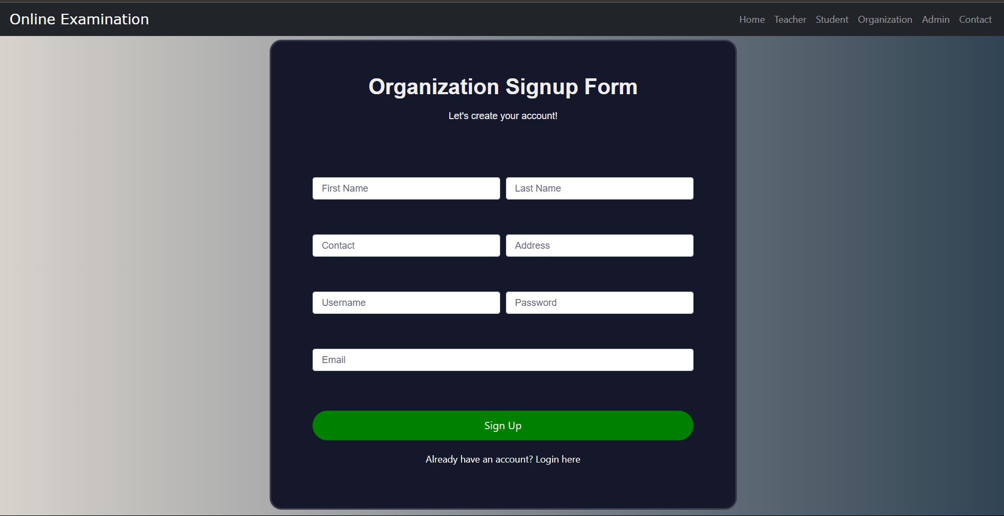

**Figure 3.3.1 Registration Pop-up form**

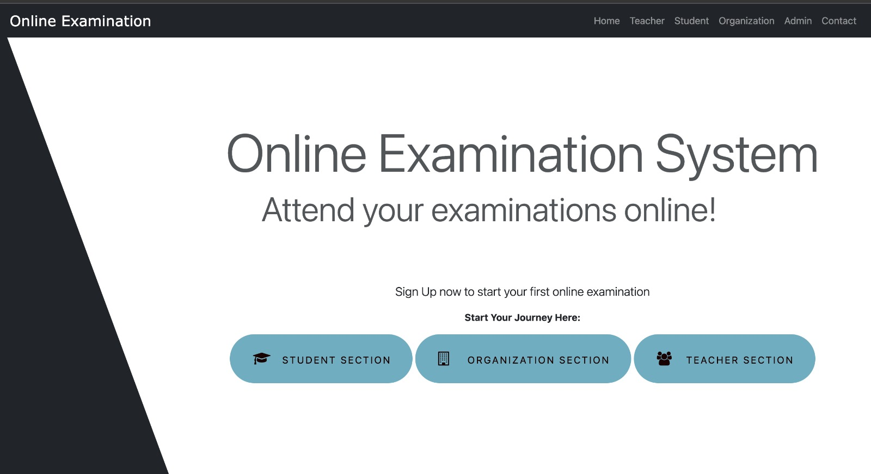

**Figure 3.3.2 Landing Page**

**CHAPTER 4**

**OBJECTIVE AND SCOPE**

The objective and scope section delineate the specific goals of the Online Examination Portal project and outline its scope and boundaries to provide a clear understanding of its aims and limitations.

**4.1 Specific Goals of the Project**

The primary goals of the Online Examination Portal project are as follows:

**4.1.1 Seamless Integration of Technology and Assessment:**

* To bridge the gap between traditional examination methods and modern technological advancements, enabling seamless and efficient assessments.
* To explore the integration of cutting-edge technologies, such as secure web platforms, biometric authentication, and multimedia elements, in the examination process to enhance security, accessibility, and engagement.
* To foster a harmonious amalgamation of technological innovations and the core principles of fair, transparent, and reliable assessments, catering to the evolving needs of educational institutions and learners.

**4.1.2 Development of Comprehensive Online Examination Platform:**

* To develop a comprehensive online platform offering secure and efficient examination services, including features for creating, scheduling, and conducting assessments seamlessly.
* To provide a structured framework for educational institutions to manage the entire examination lifecycle, from question bank creation and candidate registration to result generation and analysis.
* To enable educators to leverage the platform's capabilities, such as multimedia support, flexible question formats, and accessibility features, to enhance the assessment experience and cater to diverse learner needs.

**4.1.3 Enhancement of Academic Integrity and Student Well-being:**

* To empower students with a secure and fair assessment platform, promoting academic integrity and instilling a sense of purpose in their educational pursuits.
* To foster holistic well-being by mitigating stress, anxiety, and logistical challenges associated with traditional examination methods.
* To cultivate an environment of trust, transparency, and accountability in the assessment process, nurturing a positive mindset and resilience among

**4.1.4 Cultivation of Academic Community:**

* To create a vibrant online community of educational institutions, educators, and learners dedicated to leveraging the benefits of secure and efficient online assessments.
* To facilitate knowledge sharing, best practices, and collaborative efforts in examination management, catering to diverse academic requirements across geographical boundaries.
* To foster a supportive ecosystem where stakeholders can discuss challenges, seek guidance, and contribute to the continuous enhancement of online examination processes.

**4.2 Scope and Boundaries of the Work**

The scope of the Online Examination Portal project encompasses the following areas:

**4.2.1 Online Platform Development:**

* Development of a user-friendly online platform, including a responsive website and mobile application, to host secure and efficient examination services.
* Implementation of features such as exam scheduling, candidate registration, remote proctoring, multimedia question support, and real-time monitoring to enhance the examination experience and ensure integrity.
* Integration of discussion forums, tutorial resources, and personalized support to assist educational institutions and learners in leveraging the platform's capabilities effectively.

**4.2.2 Content Creation and Question Bank Management:**

* Creation and curation of a comprehensive question bank, encompassing diverse subjects, difficulty levels, and assessment formats, to cater to the varying needs of educational institutions.
* Collaboration with subject matter experts, experienced educators, and assessment specialists to ensure the accuracy, relevance, and alignment of questions with curricular standards and learning objectives.
* Implementation of robust content management systems and quality assurance processes to maintain the integrity and security of the question bank, ensuring fair and reliable assessments.

**4.2.3 Community Building and Stakeholder Engagement:**

* Establishment of online forums, discussion boards, and social media channels to foster interaction, knowledge sharing, and collaboration among educational institutions, educators, and learners.
* Organization of virtual events, webinars, and training sessions to facilitate deeper understanding, best practice sharing, and professional networking within the online examination community.
* Encouraging active participation and feedback from stakeholders to continuously enhance the platform's features, usability, and alignment with evolving assessment needs.

**CHAPTER 5**

**METHODOLOGY**

The methodology section outlines the detailed explanation of the development process adopted for Online Examination Portal and the technologies used along with the justification for their selection.

**5.1 Detailed Explanation of the Development Process**

The development process for our "Online Exam Management" platform followed a systematic approach to ensure a robust and user-friendly solution. The process consisted of several key stages:

**5.1.1 Requirements Gathering and Analysis:**

* The project began with a comprehensive requirements gathering phase, where we consulted with potential users, including instructors, students, and educational administrators, to understand their needs and pain points.
* Detailed analysis was carried out to identify the essential features, functionalities, and security requirements for the platform.

**5.1.2 Design and Prototyping:**

* Based on the gathered requirements, we designed the user interface (UI) and user experience (UX) for the platform, focusing on creating an intuitive and user-friendly interface.
* Low-fidelity prototypes were developed with help of our seniors and took inspirations from some of their work to visualize the layout, navigation flow, and interactive elements of the platform.
* Iterative feedback sessions were conducted with potential users to refine the design and ensure it met their expectations.

**5.1.3 Testing and Quality Assurance:**

* Rigorous testing was conducted, using Selenium for automation, to identify and fix bugs, errors, or inconsistencies.
* User Acceptance Testing (UAT) ensured the platform met requirements and user expectations.

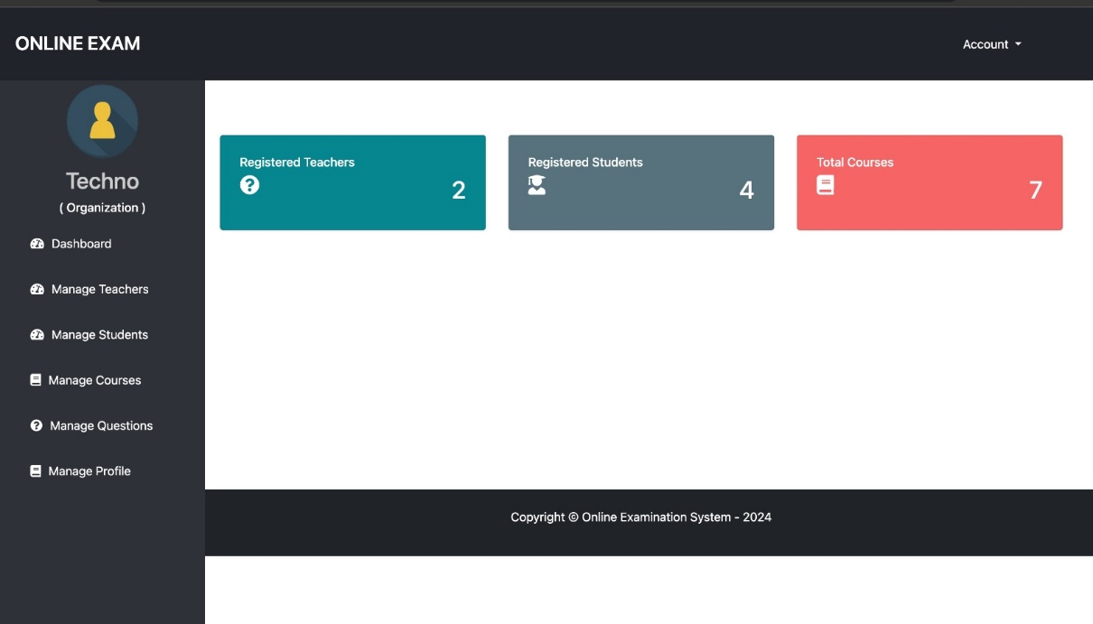

**Figure 5.1.3.1 Organization Dashboard**

**5.1.4 Monitoring and Maintenance:**

* Continuous monitoring and maintenance are performed to ensure the stability, performance, and security of the platform.
* Regular updates and improvements are rolled out based on user feedback and emerging requirements.

**5.2 Technologies Used and Justification for Their Selection**

The technologies selected for our "Online Examination Portal" platform have been carefully chosen based on their suitability for achieving the project's goals, requirements, and technical considerations. The technologies used include:

**Frontend:**

* HTML, CSS, and JavaScript Justification: These web technologies provide a solid foundation for building responsive and interactive user interfaces, ensuring cross-browser compatibility and accessibility.

**Backend:**

* Django (Python web framework) Justification: Django is a high-level Python web framework that promotes rapid development, security, and scalability, making it an ideal choice for developing robust backend systems.

**Database:**

* For development and testing:
  + SQLite: SQLite is a lightweight, file-based database management system that is well-suited for small to medium-sized applications, providing a simple and efficient solution for data storage and retrieval during the development and testing phases.
* For production deployment:
  + MySQL: MySQL is a robust, scalable, and widely-used relational database management system, suitable for enterprise-level applications. It offers features like advanced query optimization, high performance, and support for large data volumes, making it an ideal choice for the production deployment of our online examination platform.

**Testing and Quality Assurance:**

* Selenium Justification: Selenium is a widely-used tool for automating web browser interactions, enabling efficient testing and ensuring the platform's functionality and user experience across different browsers and environments.

**Version Control and Collaboration:**

* Git and GitHub Justification: Git is a distributed version control system that allows for efficient collaboration and code management, while GitHub provides a platform for hosting the project repository and facilitating team communication.

**Table 5-1: Technology Stack**

| **Component** | **Technology** |
| --- | --- |
| Frontend | HTML, CSS, JavaScript |
| Backend | Django (Python web framework) |
| Database | SQLite, MySQL |
| Testing and Quality Assurance | Selenium |
| Version Control and Collaboration | Git, GitHub |

The chosen technology stack was carefully selected to ensure a robust, secure, and scalable platform while leveraging industry-standard tools and frameworks for efficient development and maintenance.

**CHAPTER 6**

**SYSTEM ARCHITECTURE**

The system architecture section provides an overview of the architecture of the Online Examination Portal platform, including descriptions of its frontend, backend, and database components.

**6.1 Overview of the Architecture of Online Examination Portal Platform**

The system architecture of our "Online Examination Portal" platform is designed to be scalable, secure, and efficient. It follows a modern web application architecture, leveraging industry-standard technologies and best practices.

The platform consists of three main components: the frontend, backend, and database, working together cohesively. The frontend, built with HTML, CSS, and JavaScript, handles user interactions and communicates with the backend through secure APIs.

The backend, developed using Django, acts as the central hub, managing business logic, user authentication, exam data processing, and database interfacing. Django's security features and modular structure contribute to robustness and maintainability.

For development and testing purposes, SQLite was used as the database, serving as persistent storage for exam data, user information, and metadata, providing efficient data management and querying capabilities. However, for the production deployment, MySQL was chosen as the primary database solution to leverage its robustness, scalability, and support for enterprise-level applications.

This architecture enables efficient exam creation, administration, and grading while ensuring data integrity and user privacy.

**6.2 Description of Frontend, Backend, and Database Components**

**6.2.1 Frontend Component:**

* The frontend component is responsible for rendering the user interface and handling user interactions.
* Developed using HTML, CSS, and JavaScript, it provides a responsive and user-friendly experience.
* The frontend communicates with the backend through secure APIs to fetch data and process user requests.
* Key features include intuitive navigation, exam interface, and user dashboards.

**6.2.2 Backend Component:**

* The backend serves as the core logic and functionality, handling user authentication, exam data processing, and business logic.
* Built using the Django web framework, it consists of modular services and APIs that interact with the frontend and database.
* The backend implements security measures like authentication, role-based and access control

**6.2.3 Database Component:**

* The database component stores and manages the platform's data, including user profiles, exam details, and results.
* For development and testing, SQLite, a lightweight and file-based database, was used for efficient data storage and retrieval.
* However, for the production deployment, MySQL was chosen as the primary database solution to leverage its robustness, scalability, and support for enterprise-level applications.
* The database schema is designed to optimize performance, minimize redundancy, and ensure data integrity.
* Data access is controlled through secure APIs and permissions, preventing unauthorized access.

**CHAPTER 7**

**IMPLEMENTATION DETAILS**

In this section, we delve into the technical aspects of creating the Online Examination Portal platform, covering prototype creation, development environment setup, and database design.

**7.1 Data flow Diagram**

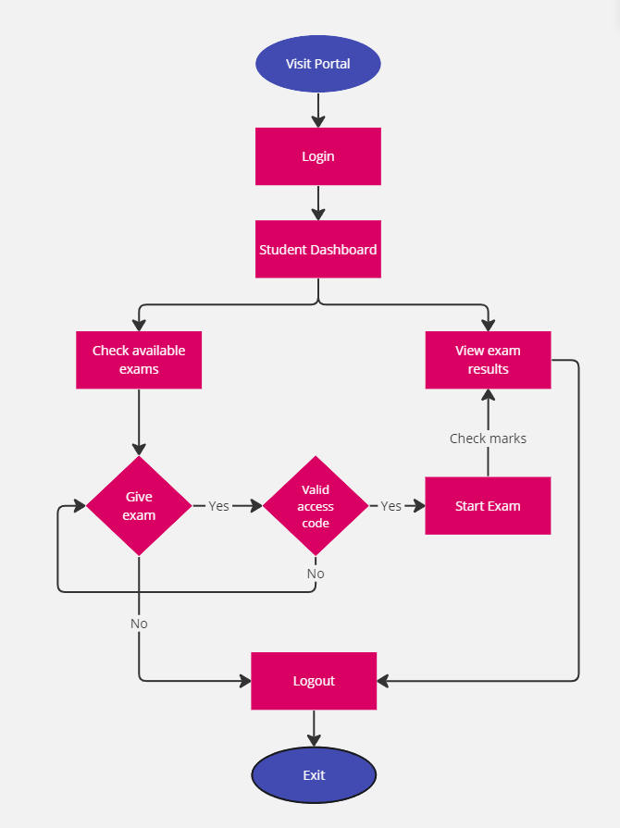

**Figure 7.1.1 Online Examination Portal – DFD**

**7.2 Development Environment Setup**

For the frontend development, we utilized HTML, CSS, and JavaScript, along with the Django web framework for the backend. This setup provided a robust and industry-standard environment for web application development, ensuring compatibility and streamlining the development process.

**7.3 Data Models and Database Design**

The data models and database design were carefully planned and structured to ensure efficient data storage and retrieval. Entity-Relationship (ER) diagrams guided the process of identifying and structuring the relevant data entities. For development and testing purposes, SQLite, a lightweight and file-based database management system, was utilized due to its simplicity and ease of integration. However, for the production deployment, MySQL was chosen as the primary database solution to leverage its robustness, scalability, and support for enterprise-level applications.

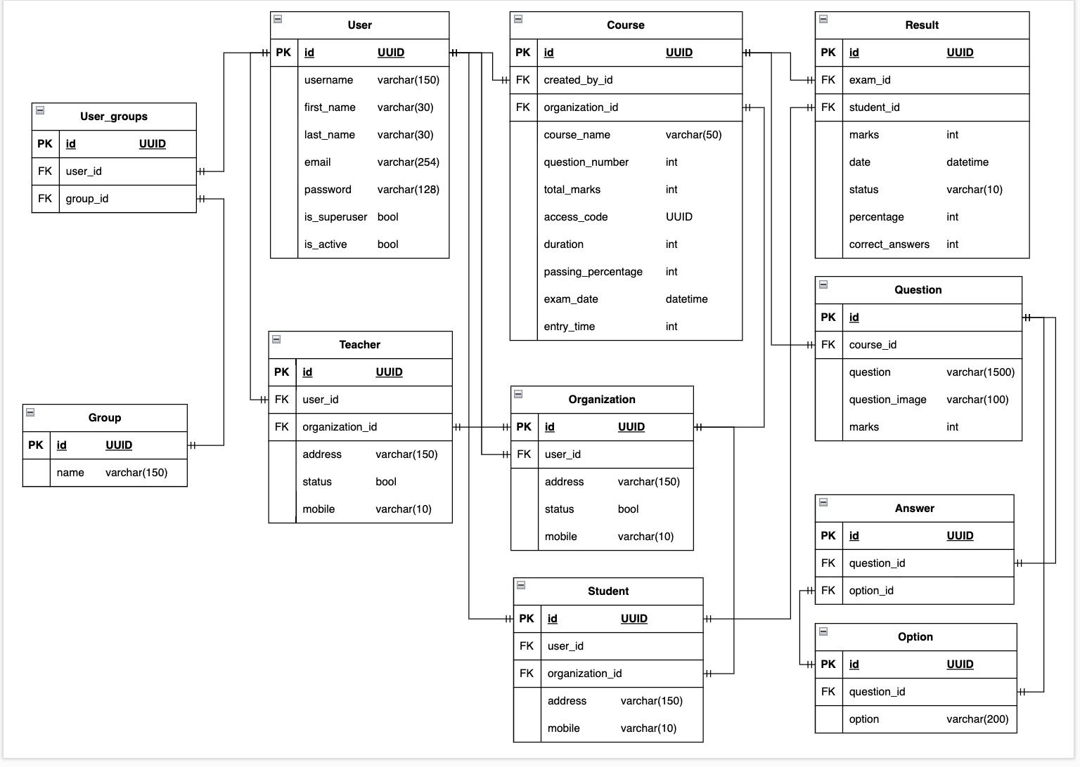

**Figure 7.3.1 Online Examination Portal – (ER Diagram)**

**7.4 Implemented Code**

* Code for uploading xlsx files to upload question from the xlsx file

@user_passes_test(is_teacher)

def teacher_upload_questions_file(request):

    if request.method=="POST":

        import pandas as pd

        import openpyxl

        import uuid

        from openpyxl_image_loader import SheetImageLoader

        from exam.models import Course,Question,Option,Answer

        from django.core.files.base import ContentFile

        from io import BytesIO

        file_obj = request.FILES.get("uploadFile")

        if file_obj.content_type!='application/vnd.openxmlformats-officedocument.spreadsheetml.sheet':

            messages.error(request, "Only xlsx files allowed")

            return redirect(request.META.get("HTTP_REFERER"))

        df = pd.read_excel(file_obj,header=None,engine='openpyxl')

        df_list = df.values.tolist()

        # Load the Excel workbook and sheet

        pxl_doc = openpyxl.load_workbook(file_obj)

        sheet = pxl_doc['Sheet1']

        image_loader = SheetImageLoader(sheet)

        last_row = sheet.max_row

        course_name = df_list[0][0]

        course_obj = Course.objects.filter(course_name=course_name).first()

        if not course_obj:

            messages.error(request, "No course with the provided name")

            return redirect(request.META.get("HTTP_REFERER"))

        self_organization = TeacherModel.Teacher.objects.get(user=request.user.id).organization

        if self_organization!=course_obj.organization:

            messages.error(request, f"No course found by the name {course_name} in your organization {self_organization}")

            return redirect(request.META.get("HTTP_REFERER"))

        for row_number in range(1, last_row + 1):

            question = Question()

            row = df_list[row_number - 1]

            question.question = row[1]

            question.marks = row[2]

            question.course = course_obj

            try:

                image = image_loader.get("D"+str(row_number))

            except Exception as e:

                image = None

            if image:

                image_rgb = image.convert('RGB')

                output = BytesIO()

                image_rgb.save(output, format='JPEG')

                image_data = output.getvalue()

                question.question_image.save(f'{uuid.uuid4().hex}.jpg', ContentFile(image_data))

            question.save()

            course_obj.question_number+=1

            course_obj.total_marks+=question.marks

            course_obj.save()

            answer = row[-1]

            for option in row[4:-1]:

                op =  Option.objects.create(option=option, question=question)

                op.save()

                if answer == option:

                    ans = Answer.objects.create(answer=op,question=question)

                    ans.save()

        messages.success(request, f"questions added in course {course_name}")

        return redirect(request.META.get("HTTP_REFERER"))

    else:

        return render(request,"teacher/teacher_upload_question_file.html")

* Code for approval of teacher by admin

@login_required(login_url="adminlogin")

@user_passes_test(is_admin)

def approve_teacher_view(request, pk):

    if request.method == "POST":

        teacher = TMODEL.Teacher.objects.get(id=pk)

        teacher.status = True

        teacher.save()

    else:

        print("Not a valid request type")

        return HttpResponseRedirect("/admin-view-pending-teacher")

    return redirect('approve-teacher', pk = pk)

@login_required(login_url="adminlogin")

@user_passes_test(is_admin)

def reject_teacher_view(request, pk):

    teacher = TMODEL.Teacher.objects.get(id=pk)

    user = User.objects.get(id=teacher.user_id)

    user.delete()

    teacher.delete()

    return HttpResponseRedirect("/admin-view-pending-teacher")

**CHAPTER 8**

**RESULTS AND EVALUATION**

**8.1 Presentation of Project Outcomes**

**Figure 8.1.1 Project Outcomes**

**8.2 Interpretation of Results**

The outcomes achieved by our "Online Exam Management" platform demonstrate its effectiveness in addressing the challenges faced by educational institutions in conducting secure and efficient online examinations. The successful implementation of robust security measures has ensured the integrity of the examination process, preventing malpractices and safeguarding the fairness of assessments.

The streamlined exam management capabilities of the platform have significantly reduced the administrative overhead for instructors and administrators, enabling them to focus more on the educational aspects of their roles. The enhanced user experience provided by the intuitive interface and seamless navigation has contributed to a positive examination environment for students.

**8.3 Limitations:**

While our "Online Exam Management" platform has achieved notable success, it is essential to acknowledge certain limitations and areas for potential improvement:

●**Technical Limitations:** Although the platform is designed to be compatible with various devices and operating systems, there may be instances where specific hardware or software configurations could lead to compatibility issues, potentially affecting the user experience.

●**Network Dependence:** The platform relies on a stable internet connection for optimal performance. Users in areas with limited or unreliable internet access may experience challenges in accessing the platform or encounter interruptions during examinations.

●**Scalability Constraints:** While the current architecture is scalable, there may be practical limitations in terms of hardware resources or infrastructure capacity, which could impact the platform's ability to handle extremely large user loads or data volumes.

●**Content Management:** As the number of examinations and users grows, efficient content management and organization may become more challenging, potentially requiring additional features or administrative tools.

●**Accessibility Considerations:** While the platform strives for accessibility, there may be instances where certain disabilities or assistive technology requirements are not fully addressed, potentially hindering equal access for all users.

**8.4 The Future Scope of the Project:**

**1. Continuous Platform Enhancement:** Regular updates and improvements to the online examination platform, incorporating feedback from stakeholders and addressing evolving assessment needs.

**2. Integration of Emerging Technologies:** Adoption of cutting-edge technologies, such as artificial intelligence, machine learning, and advanced analytics, to enhance security, streamline processes, and provide personalized assessment experiences.

**3. Expansion and Partnerships:** Establishing collaborations with educational institutions, assessment bodies, and technology partners globally, enabling broader reach and seamless integration with diverse academic ecosystems.

**4. Diversification of Assessment Offerings:** Introduction of specialized assessment modules and services tailored to specific domains, curricula, or industry requirements, catering to the diverse needs of learners and professionals.

**5. Fostering an Educational Community:** Building a vibrant online community of educators, learners, and assessment professionals, facilitating knowledge sharing, best practices, and collaborative initiatives to drive innovation in the field of online examinations.

**6. Research and Development:** Encouraging research and publications in the areas of online assessment, learning analytics, and educational technology, contributing to the advancement of knowledge and best practices in the sector.

**7. Exploration of Innovative Assessment Methods:** Investigating and implementing innovative assessment approaches, such as gamification, adaptive testing, and immersive simulations, to enhance learner engagement, personalization, and the evaluation of higher-order cognitive skills.

**CHAPTER 9**

**CONCLUSION**

Our "Online Exam Management" platform represents a significant stride towards revolutionizing the assessment process in educational institutions. By leveraging cutting-edge technologies and adhering to industry best practices, we have successfully developed a secure, efficient, and user-friendly solution for conducting online examinations.

While navigating various challenges and limitations, our platform's commitment to upholding academic integrity, enhancing the examination experience, and providing scalable solutions remains unwavering. As we look toward the future, we envision continuous growth, technological advancements, and a lasting impact on the educational landscape.

**References**

[1] Muna R. Hameed, Firas. A. Abdullatif . Online Examination Systems International Advanced Research Journal in Science, Engineering and Technology

<https://www.researchgate.net/publication/317306939_Online_Examination_System>

[2] Subham Baluni, Ms. Monika Belwal, Sudhanshu Gaur. Online Examination Systems: A Review.

<https://www.irjmets.com/uploadedfiles/paper/issue_5_may_2022/24792/final/fin_irjmets1671109584.pdf>

[3] Kerryn Butler-Henderson, & Joseph Crawford. A systematic review of online examinations: A pedagogical innovation for scalable authentication and integrity

<https://www.sciencedirect.com/science/article/pii/S0360131520302220>

[4] IMPLEMENTING AN ONLINE EXAMINATION SYSTEM Nicholas A. Omoregbe, Ambrose A. Azeta, Adewole Adewumi, Ajayi O. Oluwafunmilola. IMPLEMENTING AN ONLINE EXAMINATION SYSTEM

<https://www.researchgate.net/publication/308881144_IMPLEMENTING_AN_ONLINE_EXAMINATION_SYSTEM>

**APPENDICES**

**GitHub Link: -** **<https://github.com/priyanshuarora595/online_examination>**

**Host Link: -** [**https://onlinexamination.pythonanywhere.com/**](https://onlinexamination.pythonanywhere.com/)